|  |  |  |  |
| --- | --- | --- | --- |
| 1 | | 21,744 | |
| **NUMERO DE FRONTERAS** | | **ENERGIA AGREGADA** | |
|  | | | |
| 29,990,904 | 59 | | 1,266,413 |
| INGRESO 2020 | DÍAS CERTIFICADOS 2020 | | ENERGIA RESPALDADA 2020 |
|  | | | |
| 14,713,576 | 30 | | 652,320 |
| INGRESO 2021 | DÍAS CERTIFICADOS 2021 | | ENERGIA RESPALDADA 2021 |

**HISTORICO REINTEGRO DDV**

|  |  |  |
| --- | --- | --- |
|  | **2020** | **2021** |
| **ENE** | - | 11.65 |
| **FEB** | - | 3.06 |
| **MAR** | - | - |
| **ABR** | - | - |
| **MAY** | - | - |
| **JUN** | - | - |
| **JUL** | - | - |
| **AGO** | 0.51 | - |
| **SEP** | - | - |
| **OCT** | 5.25 | - |
| **NOV** | 12.83 | - |
| **DIC** | 11.4 | - |

**Los valores de la tabla están en millones de COP**



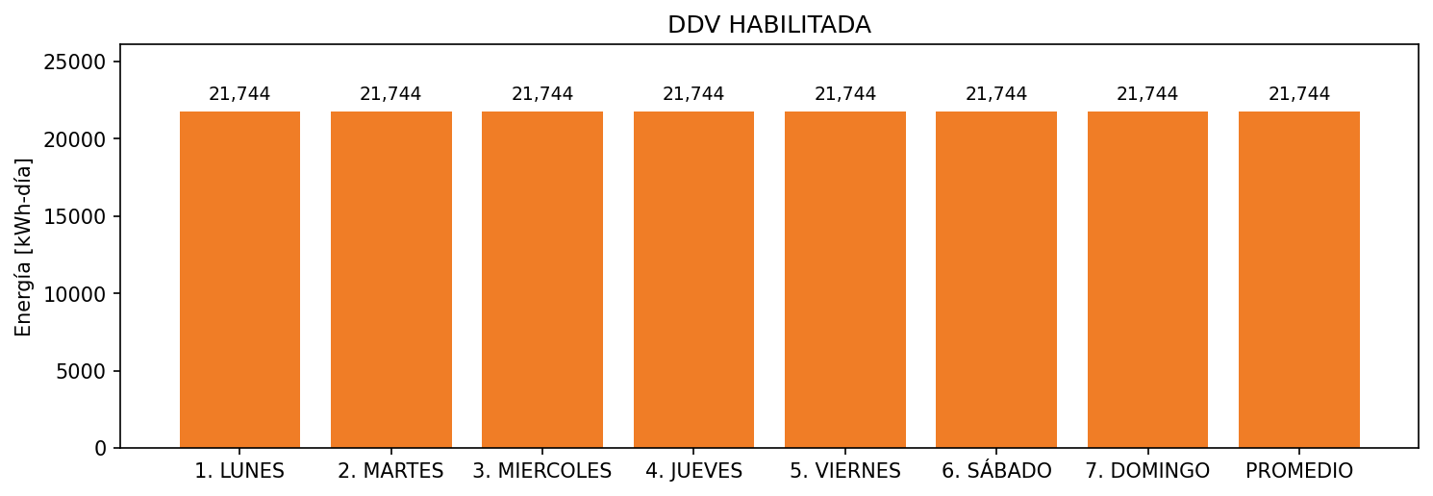

|  |  |  |  |  |  |  |  |  |  |
| --- | --- | --- | --- | --- | --- | --- | --- | --- | --- |
| **FRONTERA** | **COD SIC** | **FRT DDV** | **TIPO DDV** | **PROMEDIO** | **PRÓXIMA ACTUALIZACIÓN** | **MARGEN DE ERROR** | **ÚLTIMA PRUEBA DDV** | **DÍAS PARTICIPACIÓN** | **FECHA REFERENCIA PRÓXIMA PRUEBA DDV** |
| INDUSTRIA NACIONAL DE GASESOSAS S.A. | Frt00477 | Frt38172 | GPE | 21,744 | 2023-04-15 | NO APLICA | 2020-10-11 | 88.0 | 2021-12-18 |